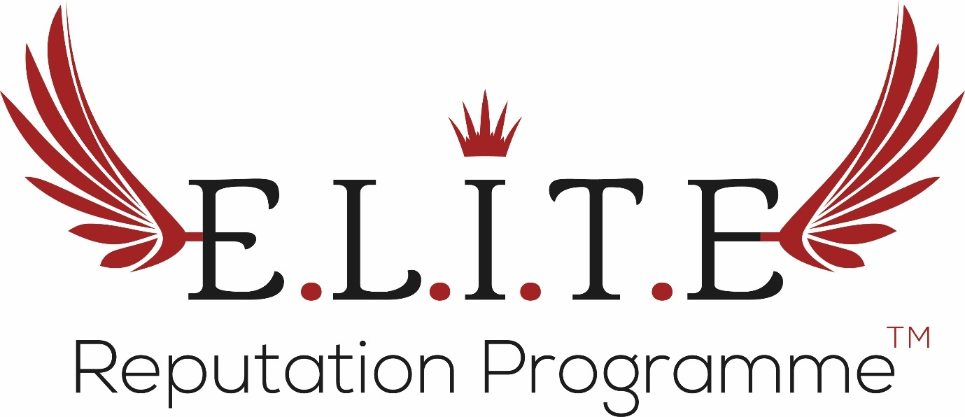

**Managing Through A Global Crisis**

**OUT OF THE ORDINARY!**

It’s a common stance in business to prepare for every and all outcomes, but how should we respond when we are faced with an unprecedented incident, that perhaps exists on a global scale? It can be overwhelming when fast moving external factors are affecting your business, everything feels urgent and it’s difficult to identify where your focus is best and most effectively placed. By sticking to a small collection of robust principles during a volatile period, you will trigger a significant and productive shift in your perspective, focus and ability to act with purpose!

**TOP TIPS FOR MANAGING THROUGH A GLOBAL CRISIS**

1. Accept Reality
   * At the earliest point, it is key to establish an accurate understanding of the external situation, and the particular factors that are likely to affect your business. Elements may arise that you have never needed to consider before. If you are unfamiliar or unclear about the emerging information, reach out to experts in your network, or in the relevant field to bolster your understanding. Professional resources are readily available via the internet, and many companies will be offering free or reduced support.
   * Do not over or under-estimate the potential impact. Base your actions or decisions on the latest Expert guidance available. Although it can be alarming, you will find that having clarity around the position of your business will bring a sense of calm and perspective.
   * Now is the time to avoid ‘fake news’. Be selective about the information that you absorb, media headlines will catastrophise and social media will be flooded with incorrect reports & personal opinion. Refine your intake of information to trusted and legitimate sources.
2. Stay Tuned
   * Keep a close eye on the news to maintain an understanding of any developments that will directly affect your business, the situation may be constantly evolving – even by the hour at times.
   * Communicate with peers and members of your industry. How are they handling the situation, are there any new actions that you can implement within your own business? And, it is essential to support your contemporaries during a crisis, above all it contributes to upholding the strength of your industry. Fortify the relationships within your network!
3. Communicate

* Be clear and transparent in all communications, do not fluff the facts. It is important to establish an honest line of explanation on behalf of your business, this can be generally distributed or personalised where required.
* Ensure that all lines of communication are pro-actively up to date and manned: phone lines, social media channels, your website, front-of-house.
* You will encounter clients and customers who panic or rage. While being supportive, you should not absorb or perpetuate their anxieties. It is OK to be assertive and conclude contact.

1. Act Swiftly

* Keep your staff, clients and suppliers swiftly up to date, ensure they are clear on any actions your business is taking that will impact them. And reassure your business advocates of all measures being taken to account for their safety, health or wellbeing.
* You can communicate broadly through your social media channels, your website, a newsletter.

1. Be Agile and Adaptable

* You may have to amend the format of how your business has been functioning, for example your consultations can be handled online and your meetings via video or conference call. These adjustments are easy, there’s a plethora of resources available to put these changes in place instantly.
* Utilise your social media channels to deliver live presentations or Expert advice and demonstrations to your peers and customers.

1. Give Back

* You may find yourself with more time on your hands, use this wisely! If you have the resources to supply your expertise to your industry and the public, do it. Cosmetic Doctors can dust-off their GP skills, product brands can give from their supplies, and everyone can make a contribution within their community. Any effort, no matter how big or small makes a difference and an impact.

**YOU WILL GET THROUGH THIS**

CRISIS does not mean the conclusion of your livelihood or purpose, even if you need to operate differently for a period of time. Honing your focus on future success while dealing head-on with the details at hand will ensure you’re not picking-up any pieces but you are continuing equipped by the benefit of learnings and experience.