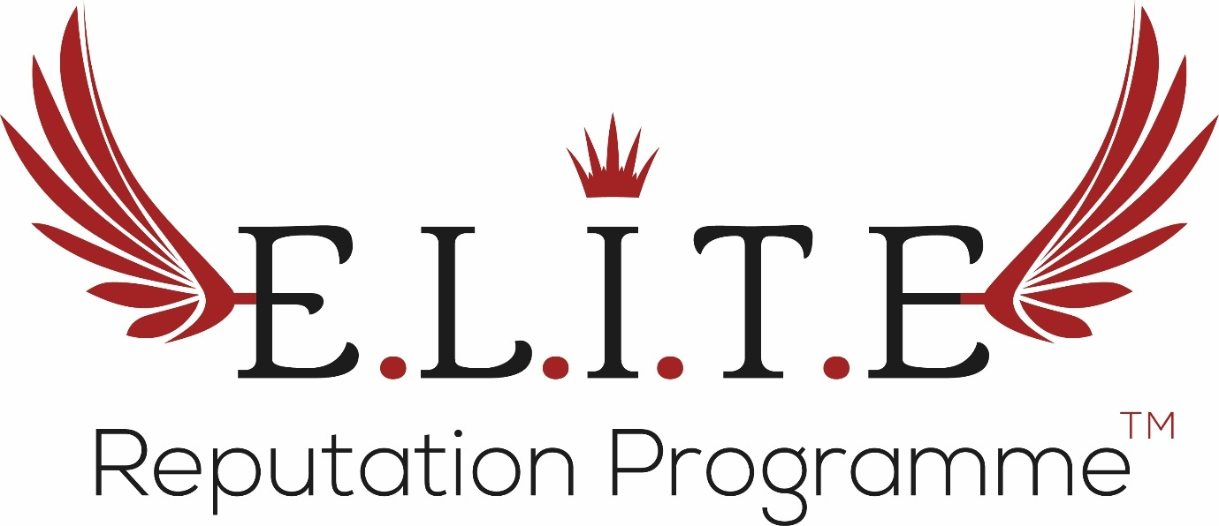

**Step 2. Compelling Content Creator**

**Exercise 2.2: Newsletters with Impact**

**RECAP:**

**Top 5 Newsletter Mistakes**

1. Too long and wordy

* Online reading style is scanning, not in-depth

1. Impersonal

* No use of names upfront, not tailored

1. From a generic email

* People want mail from people
* Company name in “From” field increases open rates by 137%!

1. No call to action

* Too many or none, make it easy for them to do in 7-12 seconds

1. WIIFM?

* Why should they care? What do they get? Personal benefits?

**Manage Expectations Upfront**

A good tip is to be clear about things right from the ‘Subscribe’ stage. With your pop-up or landing page asking for users to input their details, consider including some messaging and imagery about what they can expect – what you’ll be sending and how often:

* *“You get access to our regular monthly newsletter packed with skincare tips, insights and special offers”*

Perhaps show a preview image of what the newsletter looks like and also encourage users to add the email to their address book now so it doesn’t go into junk!

**Top Tips for Compelling Newsletters**

* Keep it short – 3-4 scrolls MAXIMUM
* Image to text ratio needs to be around 30:70
  + Spam filters!
* Allow them to easily manage preferences
  + Unsubscribe link (+ mailing address)
* TEST for success
  + Check links work correctly
  + Images loading properly (ensure each has alt text)
  + Layout doesn’t change when sending (mobile optimised)
* Consistent design and format (1-column best for mobile)
  + Good spacing, not too cluttered

**EXERCISE: Writing Compelling Subject Lines**

We’ve spoken about how important your subject line is – something like *‘KPR Clinic Jan Newsletter’* is rather uninspiring and gives no incentive for the reader to open immediately.

The line needs to be under 50 characters to allow for ease of reading and SEO – preferably with keywords at the start of the sentence. The idea is to entice your readers into opening something interesting and useful – you can also refer to your marketing calendar for some inspiration on topical trends.

Most clinics should be doing a newsletter at least once per month, so let’s assume you need x12 punchy email subjects. Planning this in advance will make your life much easier, so let’s brainstorm some good subject lines now! Here are some starters for ten that you can expand on:

|  |  |
| --- | --- |
| **Action word starters**   * Meet the / your / our * Want the latest / * Heard about * Check out * Join us * Watch the * See the * Unveiling our / the * Introducing the / our * How to * Celebrate | **Description starters**   * Spring trends * Celebrity watch * Summer skin * Spotted! * Most wanted: * Top 10 * This month’s must-have / trend / * Luxury * Latest / Fastest / Newest * Best-selling * Winter survival |

**YOUR PUNCHY NEWSLETTER EMAIL SUBJECT LINES:**

|  |  |
| --- | --- |
| **Jan** |  |
| **Feb** |  |
| **Mar** |  |
| **Apr** |  |
| **May** |  |
| **Jun** |  |
| **Jul** |  |
| **Aug** |  |
| **Sept** |  |
| **Oct** |  |
| **Nov** |  |
| **Dec** |  |

**Content is Key**

When it comes to fleshing out your newsletter contents, remember to keep it 90% educational, 10% promotional content. Nobody just wants to be sold things constantly – the newsletter must give value or it will get binned. Copy needs to be concise and well-spaced; the idea is to give tiop-line information and insights and direct readers to your other channels (website, blog, social media) for more detail.

Make sure each newsletter has one main call to action (CTA) – the one thing you want readers to do. There can be other CTAs in there but positioned more as ‘if you have time’ – like reading a blog. Use colour / design for your main CTA to stand out – if this is a button or link you want people to follow.

It goes without saying that your newsletter should include links to all your main social platforms to encourage readers to join / follow and ideally SHARE your content with others, thus expanding your reach and building your list.

**Newsletter Structure**

I am a big fan of creating a consistent newsletter template, with standard sections that remain the same month by month. Not only does this make for easier advance planning, it means you can more readily delegate this task to others in your team, or an external supplier.

A suggested structure could look like this – you can of course add more sections or tweak contents, but remember the above points about newsletter length and complexity.

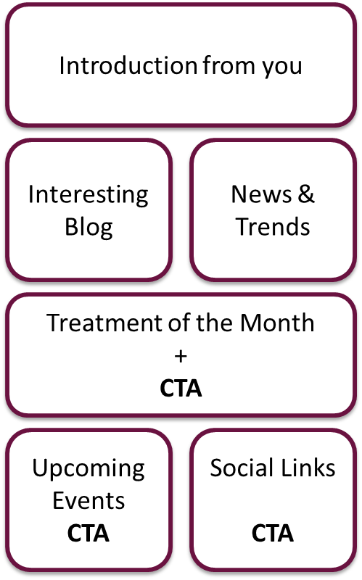

Depending on which CRM software you use, you can create a beautifully designed template with these sections very easily – then revisit each month just to drop in the new content as you need to. Saves a lot of time and effort!

**Measuring and Tracking**

Again, depending on which CRM you use (e.g. MailChimp, Paboo), there are many different options available for tracking and evaluating the efficacy of your newsletters. At a minimum, you should check once per month to see:

* How many on your list opened the newsletter at all?
  + Don’t be discouraged, this allows you to instantly segment engaged vs/ disengaged patients and tailor your approach accordingly
* Which were the popular topics?
* What links / content were clicked on?
* Which offers resonated?
* What days / times was it opened?

All these insights will allow you to further optimise and refine your approach for next month’s newsletter.

**WELL DONE!**

**You have now completed Module 2.2 of the Compelling Content Creator!**